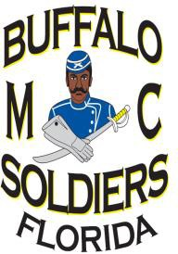**National Association of Buffalo Soldiers & Troopers**

**Motorcycle Club – Tampa Bay Chapter**

February 3, 2022

Greetings,

The Buffalo Soldiers Motorcycle Club of Florida, Inc., (BSMC, Tampa Bay Chapter) announces its 2022 “Ready Forward College Scholarship” program for high school seniors within the following counties: Hillsborough, Pinellas, Hernando, Pasco, Polk and Manatee Four (4) $500.00 scholarships will be awarded to two male and two female students based on their academic achievement, community service and other criteria as detailed in the application package.

**PRESIDENT**

**Michael “Corp” Corpening**

**VICE PRESIDENT**

**John “Enforcer” Wise**

**SECRETARY**

**Tracy “Nuubian” Harriford-Lawton**

**TREASURER**

**Terrence “T-Bone” Ward**

**BUSINESS MANAGER**

**Benjamin “Big MC” McBride**

**SERGEANT AT ARMS**

**Darryl “Bear” Hoper**





**We Can, We Will!**

**NABSTMC Tampa Chapter**

**P.O. Box 292791**

**Tampa, FL 33687-2791**

**EIN: 59-3587763**

**www.bsmcflorida.org**

All applications must be completed and postmarked by midnight on March 25, 2022. Interested applicants can view and download the application from our website www.bsmcflorida.org or you may duplicate the attached application. Late or incomplete applications will not be considered.

The BSMC, Tampa Bay Chapter is a non-profit organization whose purpose is to educate the public on the history of the original Buffalo Soldiers and their contribution to the growth of this country while our members serve as positive role models for youth in our communities.

If you have questions, please contact Mr. Anthony “Smage” Browning, the Scholarship Committee Chairperson, at 757-871-2380 or via email at



btonyb29@gmail.com. We look forward to hearing from your students.

Respectfully,

Michael Corpening

Michael “Corp” Corpening

President

National Association of Buffalo Soldiers and Troopers Motorcycle Club

Tampa Bay Chapter

**National Association of Buffalo Soldiers and Troopers Motorcycle Club**

**Tampa Bay Chapter**

**Buffalo Soldiers Motorcycle Club of Florida, Inc.**

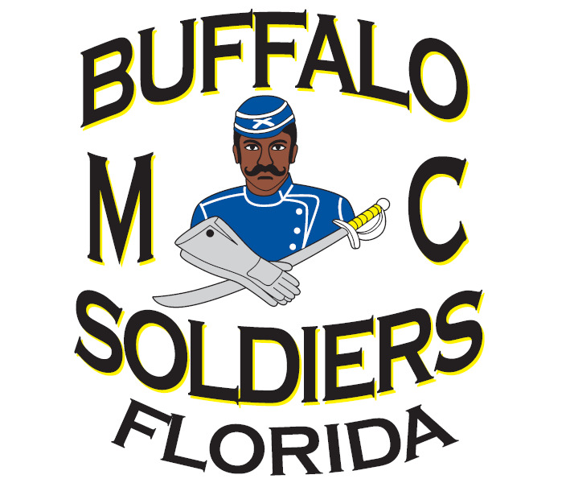

**Ready Forward College Scholarship Application**

Application Deadline

Postmarked by March 25, 2022

**Point of Contact for additional questions or information:**

Mr. Anthony “Smage” Browning, Scholarship Chairperson

(757) 871-2380-/BtonyB29@gmail.com

Mrs. Tammie Robinson-Ward, Co-Chairperson

(216) 322-3193/TTTammie@hotmail.com

Mrs. Camey Bell, Committee Member

(910) 670-3361/mrsbell1@hotmail.com

Mrs. Kathy Smith Committee Member

(813) [495-7546/mzsmith060809@gmail.com](mailto:495-7546/mzsmith060809@gmail.com)

Mr. Spellman LeBlanc Jr., Committee Member

(813) 857-4782/leblanc_family@hotmail.com

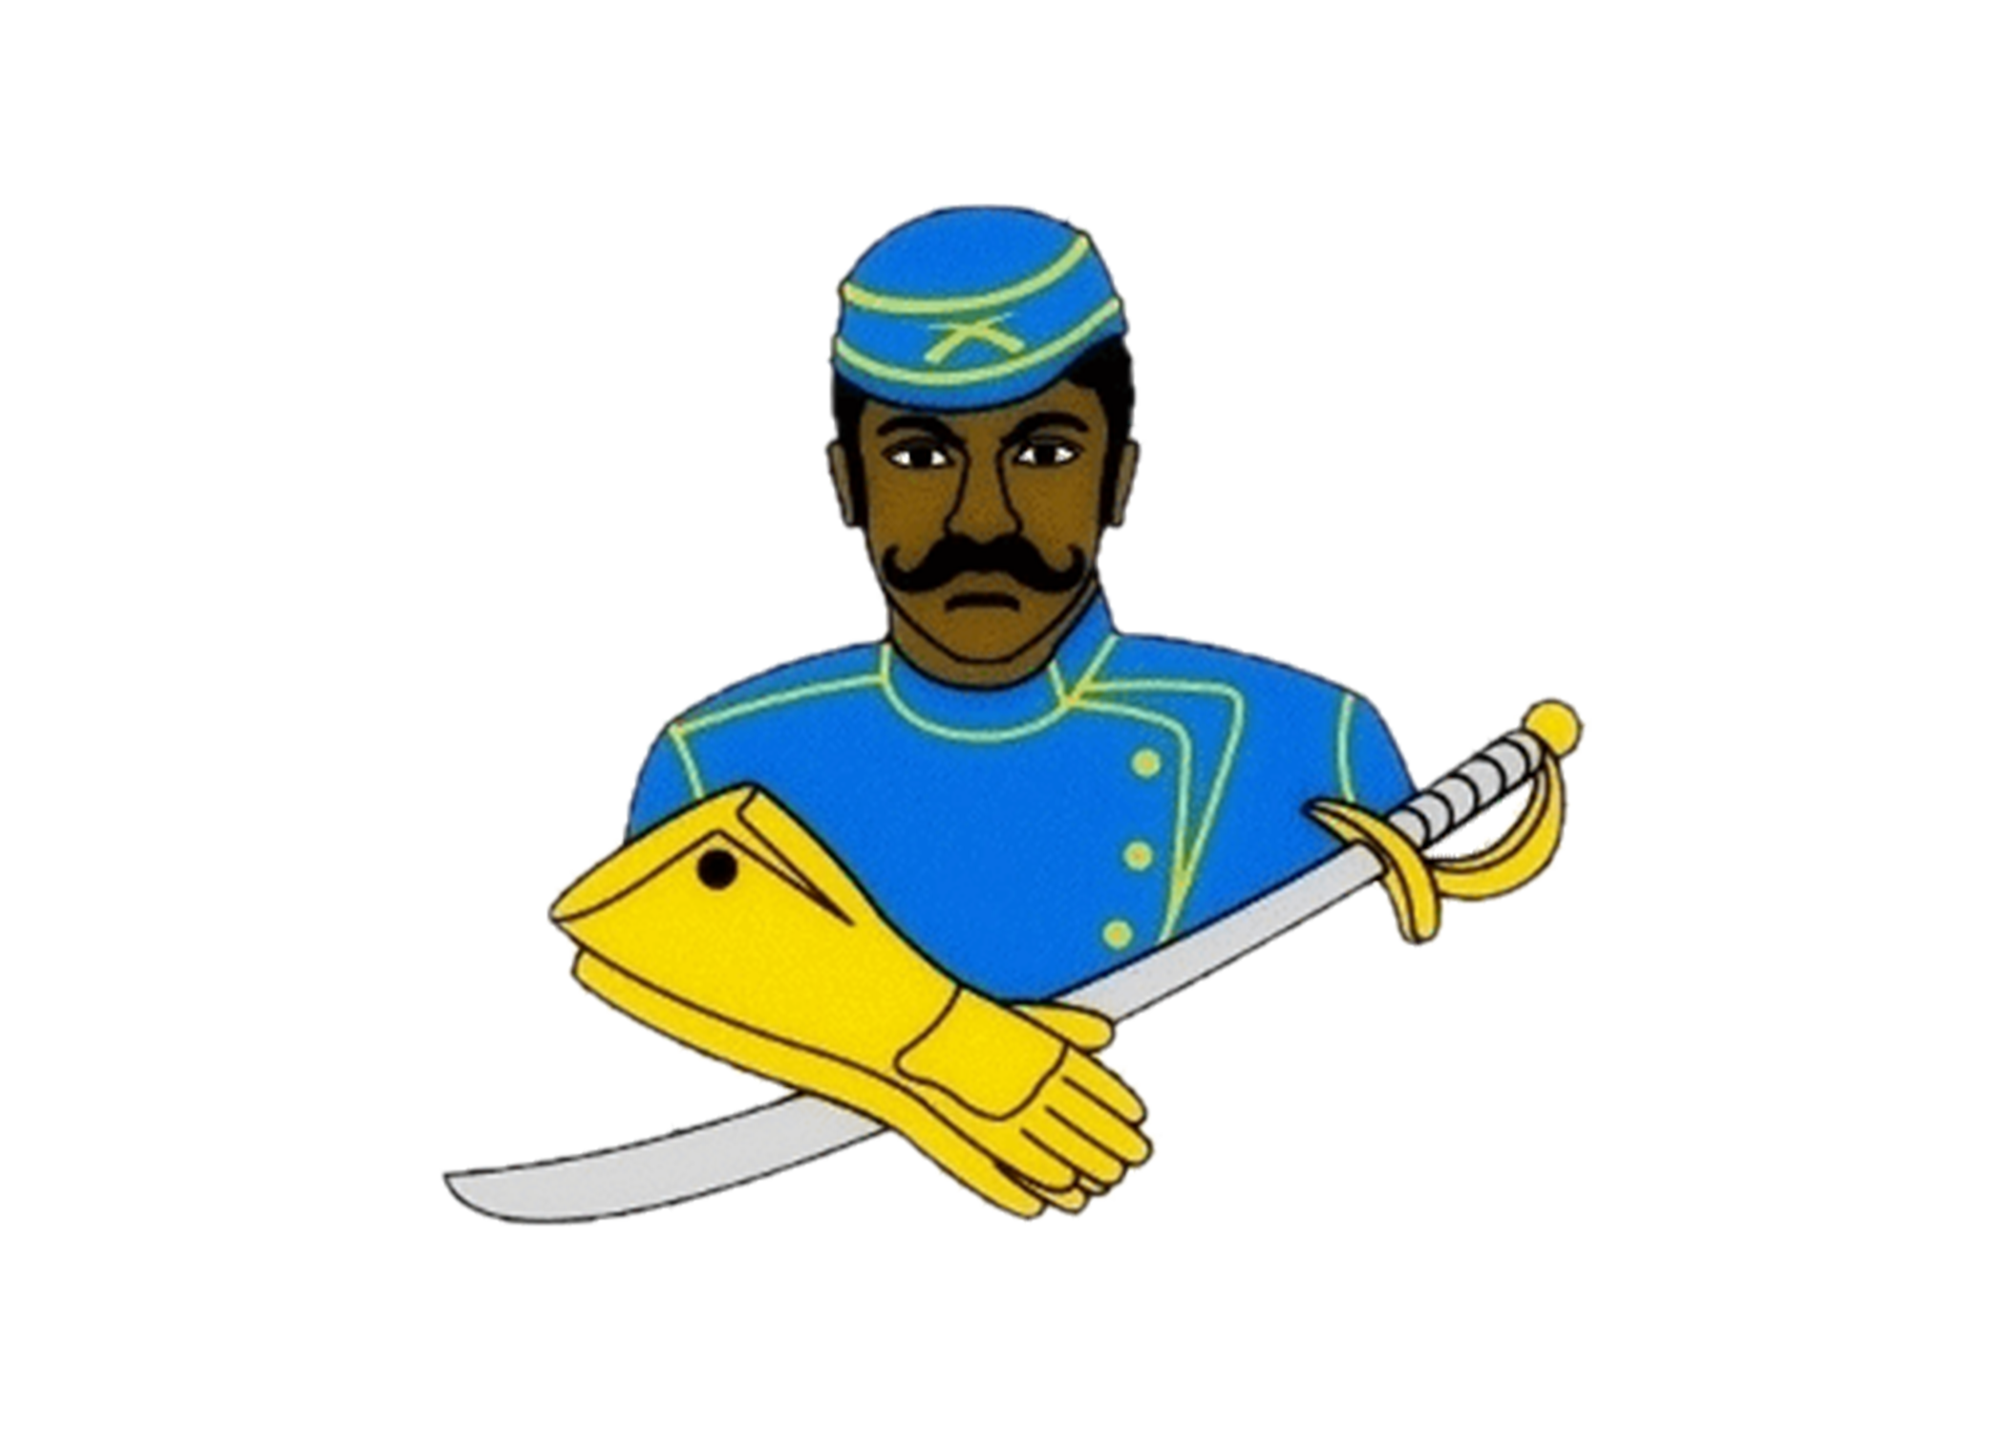**National Association of Buffalo Soldiers & Troopers Motorcycle Club (NABSTMC)**

2022 Scholarship Program

http://www.nabstmc.com/scholarship

The philosophy of the National Association of Buffalo Soldiers and Troopers Motorcycle Club is:

* To promote the history of African American veterans
* To be a positive role model for youth in our community
* To support our veterans by visiting local veterans, their families, and supporting our fallen heroes
* To support charitable organizations in our community
* To uphold the traditions and standards of the National Association of Buffalo Soldiers and Troopers Motorcycle Club
* To promote motorcycle safety in our community

The National Association of Buffalo Soldiers and Troopers Motorcycle Club (NABSTMC) is made up of five (5) Frontiers (Northeast, Southeast, Great Lakes, Central, and Western), which encompasses 35 states with an international chapter located in Germany. The NABSTMC has over 120 chapters organizational wide.

There will be a total of $10,500.00 awarded per frontier. A single National Scholarship of $5,000 will be awarded to one recipient. The NABSTMC will award a grand total of $57,500.00 in scholarships to college-bound graduating high school seniors for the 2021-2022 school year.

The NABSTMC will mail funds, on behalf of the student, upon verification of enrollment to a post-secondary/vocational or trade school where the student will be attending. Scholarships will be awarded based on a completed application packet, which includes financial need, qualifications, essay, and supporting documentation.

Each frontier winner will take part in an interview and will be vetted by the National Scholarship Committee to determine the National Scholarship Winner.

**Instructions for candidates:**

The following are needed to complete your application:

* Applicant must be an eligible Graduating High School Senior/GED recipient during the 2021 Fall/ 2022 Summer school year who will be attending post-secondary or vocational/trade school in 2022.
* Official High School Transcript, Home School Transcript or GED Test Score (No GED Certificate)
* A 500-word essay on the topics described below in Essay Topics
* Letter of recommendation on official letter head from a teacher/guidance counselor/school administrator, and/or employer (for GED).
* Letter of recommendation on letterhead from a community service organization
* A letter of acceptance to an institution of higher learning
* Signed Release Form (enclosed)
* Parent’s signature, if student is under 18 years of age
* Prepare a letter of introduction, who you are, your accomplishments (include honors and awards to date), family background, and the degree/certificate to which you are seeking. Provide a summary on how you plan to use the scholarship, if selected. Also incorporate, how this scholarship will benefit you in giving back to your community.
* Recent professional headshot photo (In Good Taste)
* Provide Student’s name, the complete name and address of the school and/or financial aid office where the student will be attending school and student ID number. Checks will be mailed by the National Treasurer to the school via the student’s account.
* Complete all forms in its entirety. Attach additional pages, if needed.
* Incomplete packages will automatically be eliminated.

**Essay Topics:**

Write a 500-word essay (typewritten) on one of the following topics:

\*\***Do not write about the Buffalo Soldiers or Troopers Motorcycle Club**\*\*

1. What impact did the Buffalo Soldiers make in war and/or peacetime? Why is it necessary to pass this legacy on to future generations?

1. Provide specific examples of how the Buffalo Soldiers facilitated the development of roadways, national parks, and mail service.

1. The Congressional Medal of Honor is presented to the recipient by the President of the United States in the name of Congress. Please supply a brief narrative regarding a Buffalo Soldier that received this honor and what can be learned from his life, efforts, and commitment to duty.

**Submit Application:**

Applications may be downloaded from www.nabstmc.com. Under the tab scholarship, you will find the application and the email address to return the completed application once the local chapter has reviewed it. **The application must go to the local chapter first (Tampa).** Completed applications and required documents must be scanned and emailed to [btonyb29@gmail.com](mailto:btonyb29@gmail.com). You can also mail your application to BSMCFL Tampa Bay Chapter, Attn: Scholarship Committee Chairperson P.O. Box 2929791 Tampa, FL 33687. Local chapters must forward your scholarship recipients to the respective email address for your Frontier by April 1, 2022. Subject line is your full name and State. All sealed transcripts must be sealed and sent to the mailing address below for your respective Chapter/State by April 1, 2022. **Incomplete packets will be eliminated.**

******National Association of Buffalo Soldiers & Troopers Motorcycle Club (NABSTMC)**

**Scholarship Program**

**2022 Application**

**Application Deadline: March 25, 2022**

**Name of local Buffalo Soldier Chapter: _______________________________**

**Contact Information:**

|  |  |  |  |
| --- | --- | --- | --- |
| **First Name:** |  | **Last Name:** |  |
| **Address:** |  | | |
| **City:** |  | **State:** |  |
| **Zip Code:** |  | **Email:** |  |
| **Home Phone:** |  | **Cell Phone:** |  |
| **Date of Birth:** |  | **Gender:** |  |

**Academic Information:**

|  |  |  |  |
| --- | --- | --- | --- |
| **High School Name:** |  | **City / State** |  |
| **Graduation Date:** |  | **GPA:** |  |
| **Class Rank:** |  | **Class Size:** |  |

**College Information (**If you have not finalized your college choice, provide your first-choice school.)**:**

|  |  |  |  |
| --- | --- | --- | --- |
| **College Name:** |  | **City / State:** |  |
| **Institution Type:**  **Certificate Four-Year Two-Year Vocational or Technical:** | | |  |
| **Degree Sought: Associates Bachelors Certificate** | | |  |
| **Major:** |  | | |
| **Anticipated Graduation Date:** |  |  |  |

**Applicant Service, Extracurricular Activities and Work Experience:**

Use this space to provide the applicant’s volunteer service, extracurricular activities, and work experience during the applicant’s academic career. **Do not attach a resume in lieu of completing this form. It will not be reviewed.**

|  |  |  |  |
| --- | --- | --- | --- |
| **Description** |  | | |
| **Total Hours or Average Hours per week:** |  | **Are you still participating? (yes / no)** |  |
| **Start Date:** |  | **End Date:** |  |
| **Highest Position Held:** |  | | |
|  |  | | |

|  |  |  |  |
| --- | --- | --- | --- |
| **Description** |  | | |
| **Total Hours or Average Hours per week:** |  | **Are you still participating? (yes / no)** |  |
| **Start Date:** |  | **End Date:** |  |
| **Highest Position Held:** |  | | |
|  |  | | |

|  |  |  |  |
| --- | --- | --- | --- |
| **Description** |  | | |
| **Total Hours or Average Hours per week:** |  | **Are you still participating? (yes / no)** |  |
| **Start Date:** |  | **End Date:** |  |
| **Highest Position Held:** |  | | |
|  |  | | |

**Terms & Conditions:**

I, , certify, to the best of my knowledge, that the information on this application is complete and accurate. Falsification of any information will cause my disqualification from the scholarship competition.

(1) It is my responsibility to make sure the application process is complete by the required deadline. If not, the application may be disqualified from the scholarship competition and may not be considered for an award.

(2) This application, upon receipt, becomes the property of the program sponsor.

I agree that, if selected as an award winner for the National Association of Buffalo Soldiers and Troopers Motorcycle Club Scholarship Program, the program sponsor or its agents may use my name and likeness and any other information or materials provided in connection with this program for purposes of news, publicity and advertising in all media, including but not limited to print and electronic media, press releases, internet websites and video media.

To comply with the provisions of the Family Educational and Privacy Act of 1974, I hereby grant permission for school officials to release secondary school records and other requested information, if necessary.

If you are under 18, your parent or guardian must also agree to these Terms and Conditions.

**Applicant Signature: Date:**

**Parent Signature: (**if applicable)

** **Local Chapter/Frontier must acknowledge receipt before sending to National Scholarship Committee.**

Chapter__________________________Signature____________________________________________

** National Association of Buffalo Soldiers & Troopers Motorcycle Club**

**Frontier Scholarship Representatives**

|  |  |  |  |
| --- | --- | --- | --- |
| **Frontier** | **State** | **Mailing Address** | **Contact Information** |
| Central | Arkansas | Attn: Dewayne “D-Nice” Harrison  PO Box 764135  Dallas, TX 75376 | Dwayne “D-Nice” Harrison  Dallas TX Chapter  cfscholarship@nabstmc.com |
| Kansas |
| Louisiana |
| Mississippi |
| Missouri |
| Oklahoma |
| Tennessee |
| Texas |
| Great Lakes | Illinois | Attn: Tonya “Stiletto” Harris  c/o BSMC Charleston WV  PO Box 322, Dunbar, WV 25064 | Tonya “Stiletto” Harris  Charleston WV Chapter  glfscholarship@nabstmc.com |
| Indiana |
| Kentucky |
| Michigan |
| Ohio |
| West Virginia |
| Wisconsin |
| Northeastern | Connecticut | Attn: Rosalind “BB” Graves  c/o NEF BSMC  P.O. Box 42052  Fredericksburg, VA 22407 | Rosalind “BB” Graves  Central Virginia Chapter  nefscholarship@nabstmc.com |
| Delaware |
| Maryland |
| Massachusetts |
| New Jersey |
| New York |
| Pennsylvania |
| Virginia |
| Southeastern | Alabama | Attn: George “Sloe Ryder” Henderson  PO Box 620896  Charlotte NC 28262 | George” Sloe Ryder” Henderson  Charlotte Chapter  sefscholarship@nabstmc.com |
| Florida |
| Georgia |
| North Carolina |
| South Carolina |
| Western | Arizona | Attn: Monica “Butta” Manly  c/o Albuquerque BSMC  P.O. Box 57061  Albuquerque, NM 87187 | Monica "Butta" Manly  Albuquerque NM Chapter  wfscholarship@nabstmc.com |
|  | California |
|  | Colorado |
|  | Hawaii |
|  | Nevada |
|  | New Mexico |
|  | Washington |
|  | Korea |

**Submitted by:**

Rosalind “BB” Graves

Chair, National Scholarship Committee

Email: scholarship@nabstmc.com